LAB 3
Write Python code to implement the following:
1. Predict canada's per capita income in year 2020. Use the data file canada_per_capita_income.csv file. If required, apply the necessary data processing steps. Using this build a regression model and predict the per capita income for canadian citizens in year 2020
import pandas as pd
import matplotlib.pyplot as plt
from sklearn.linear_model import LinearRegression

df3 = pd.read_csv('canada_per_capita_income.csv')

print("Dataset Preview:")
print(df3.head())

X = df3[['year']]
y = df3['per capita income (US$)']

model = LinearRegression()
model.fit(X, y)

prediction_2020 = model.predict([[2020]])

print("\nPredicted Per Capita Income in 2020:", prediction_2020[0])

plt.scatter(X, y, color='blue')
plt.plot(X, model.predict(X), color='red')
plt.xlabel("Year")
plt.ylabel("Per Capita Income (US$)")
plt.title("Canada Per Capita Income Prediction")
plt.show()

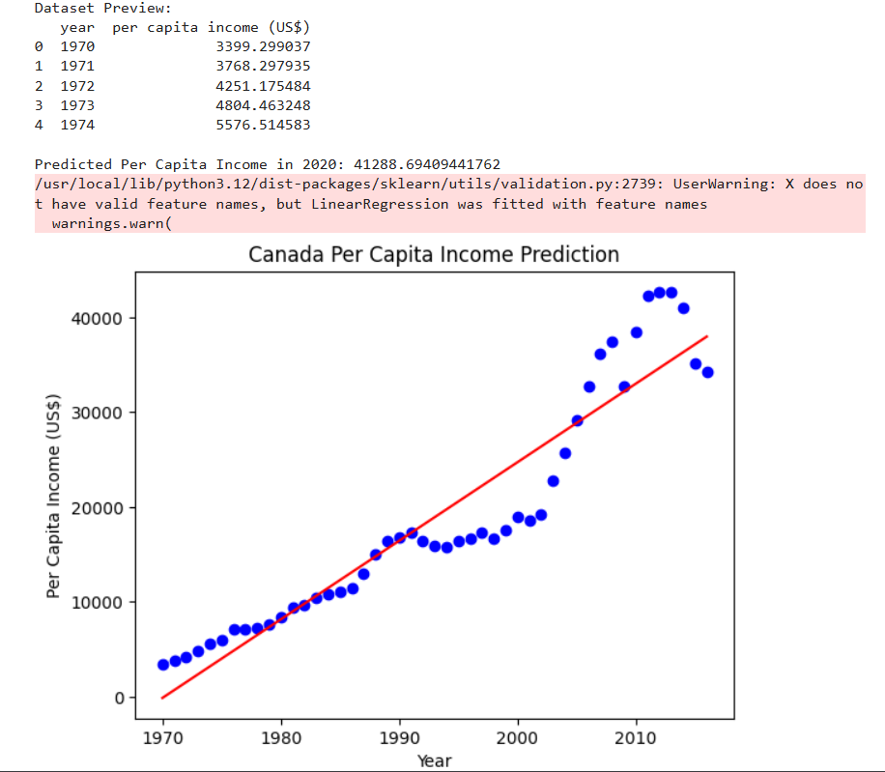

2. Predict Salary of the employee. Use the data file salary.csv file. If required, apply the necessary data processing steps. Using this build a regression model and predict the salary of the employee with 12 years of experience.
df4 = pd.read_csv('salary.csv')

print("Before Cleaning:")
print(df4.info())

df4 = df4.dropna()

print("\nAfter Cleaning:")
print(df4.info())

X = df4[['YearsExperience']]
y = df4['Salary']

# Step 6: Train model
model = LinearRegression()
model.fit(X, y)

# Step 7: Predict salary for 12 years
salary_12 = model.predict([[12]])

print("\nPredicted Salary for 12 Years Experience:", salary_12[0])

# Step 8: Plot graph
plt.scatter(X, y, color='blue')
plt.plot(X, model.predict(X), color='red')
plt.xlabel("Years of Experience")
plt.ylabel("Salary")
plt.title("Salary Prediction")
plt.show()

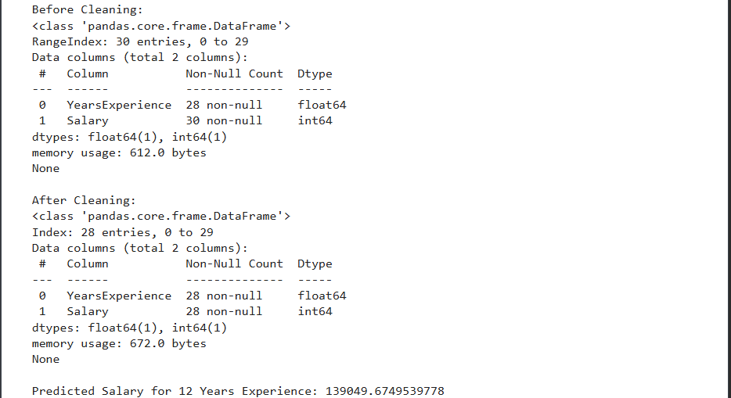

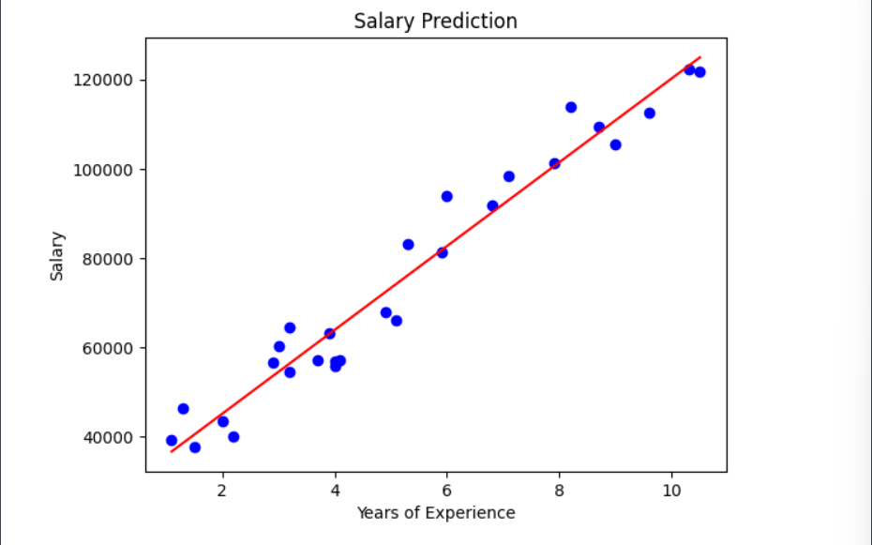

3. Write Python code to implement the following: Considering the data file hiring.csv. The file contains hiring statics for a firm such as experience of candidate, his written test score and personal interview score. Based on these 3 factors, HR will decide the salary. Given this data, you need to build a Multiple Linear Regression model for HR department that can help them decide salaries for future candidates. Using this predict salaries for following candidates,
(a) 2 yr experience, 9 test score, 6 interview score
(b) 12 yr experience, 10 test score, 10 interview score

df5=pd.read_csv('hiring.csv')
word_to_num = {
'zero': 0,
'one': 1,
'two': 2,
'three': 3,
'four': 4,
'five': 5,
'six': 6,
'seven': 7,
'eight': 8,
'nine': 9,
'ten': 10
}

df5['experience'] = df5['experience'].replace(word_to_num)

df5['experience'] = pd.to_numeric(df5['experience'], errors='coerce')

df5['experience'] = df5['experience'].fillna(0)
df5['test_score(out of 10)'] = df5['test_score(out of 10)'].fillna(df5['test_score(out of 10)'].mean())

print("\nCleaned Data:")
print(df5)

X = df5[['experience', 'test_score(out of 10)', 'interview_score(out of 10)']]
y = df5['salary($)']

model = LinearRegression()
model.fit(X, y)

salary1 = model.predict([[2, 9, 6]])
salary2 = model.predict([[12, 10, 10]])

print("\nPredicted Salary for (2 yr, 9 test, 6 interview):", salary1[0])
print("Predicted Salary for (12 yr, 10 test, 10 interview):", salary2[0])

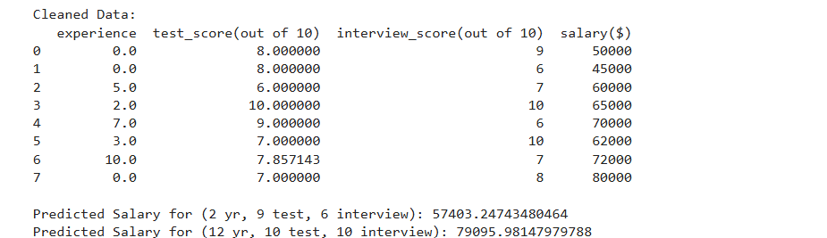

4. Considering the data file 1000_companies.csv. The file contains profit statics for a firm such as R&D Spend, Administration, Marketing Spend and State. Based on these four factors build a Multiple Linear Regression model to predict the profit. Using this predict profit for following,
• 91694.48 R&D Spend,
• 515841.3 Administration,
• 11931.24 Marketing Spend,
• Florida State
Note: If required, apply the necessary data processing steps to data files.

df6=pd.read_csv('1000_Companies.csv')
df6 = df6.dropna()
df6 = pd.get_dummies(df6, columns=['State'], drop_first=True)

print("\nEncoded Data:")
print(df6.head())

X = df6.drop('Profit', axis=1)
y = df6['Profit']

model = LinearRegression()
model.fit(X, y)

print("\nColumns Used for Training:")
print(X.columns)

profit = model.predict([[91694.48, 515841.3, 11931.24, 1, 0]])

print("\nPredicted Profit:", profit[0])
